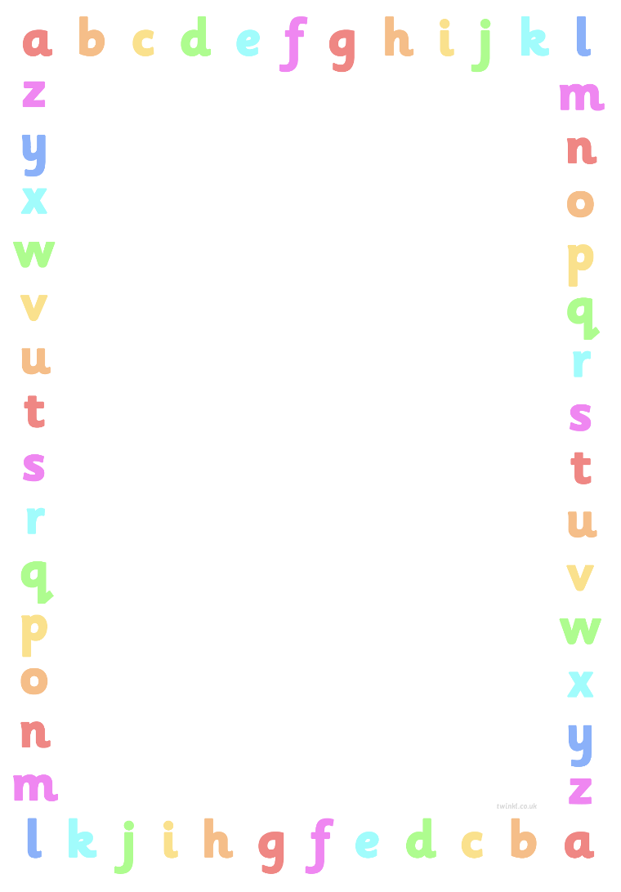
A Parents Guide To Read, Write Inc.

At Ropsley School we follow the phonics programme Read, Write Inc.
This is an extremely well established Literacy programme taught in over 5000 schools across the UK.

Here is a link to a short, informative film called What is Read, Write Inc. Phonics?
https://www.youtube.com/watch?v=sjlPILhk7bQ
This video helps you to understand how Read, Write Inc. helps your child learn to read quickly and easily and is a great starting point for parents.

We begin by learning Set 1 Speed Sounds, which are as follows:
m a s d t i n p g o c k u b f e l h r j v y w z x
We also learning the following digraphs:
sh th ch qu ng nk ck
(A digraph is simply two letters that make one sound).

Here is a really useful phonics audio guide that demonstrates how to pronounce each sound.
https://www.oxfordowl.co.uk/for-home/reading-owl/find-a-book/read-write-inc-phonics--1/phonics-pure-sounds-video
It is really important to say the sounds purely, so for example we say ‘mmm’ instead of ‘muh’. This helps children to blend the sounds when they begin to read.
It is also important that your child says the letter sound (‘mmm’) as opposed to the letter name (‘em’).

Once we have learnt the first few sounds, your child will be introduced to the concept of blending. Blending is simply putting the sounds together to make a word, for example c-a-t, cat.

For this we use a toy frog called Fred. Fred can only say the sounds and needs the children to help him read the word. Fred will say the sounds ‘c-a-t’ and the children will respond with ‘cat’. This is called Fred Talk.
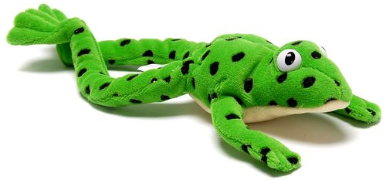

The link to the video below explains how to support your child with blending once they reach this stage. The relevant phonics flashcard will be given to your child once they learn the sound in their Read, Write Inc. lesson.
https://www.youtube.com/watch?v=MNyFikwNQTg

If you have any questions about your child’s Read, Write Inc. journey, please do not hesitate to contact us.

