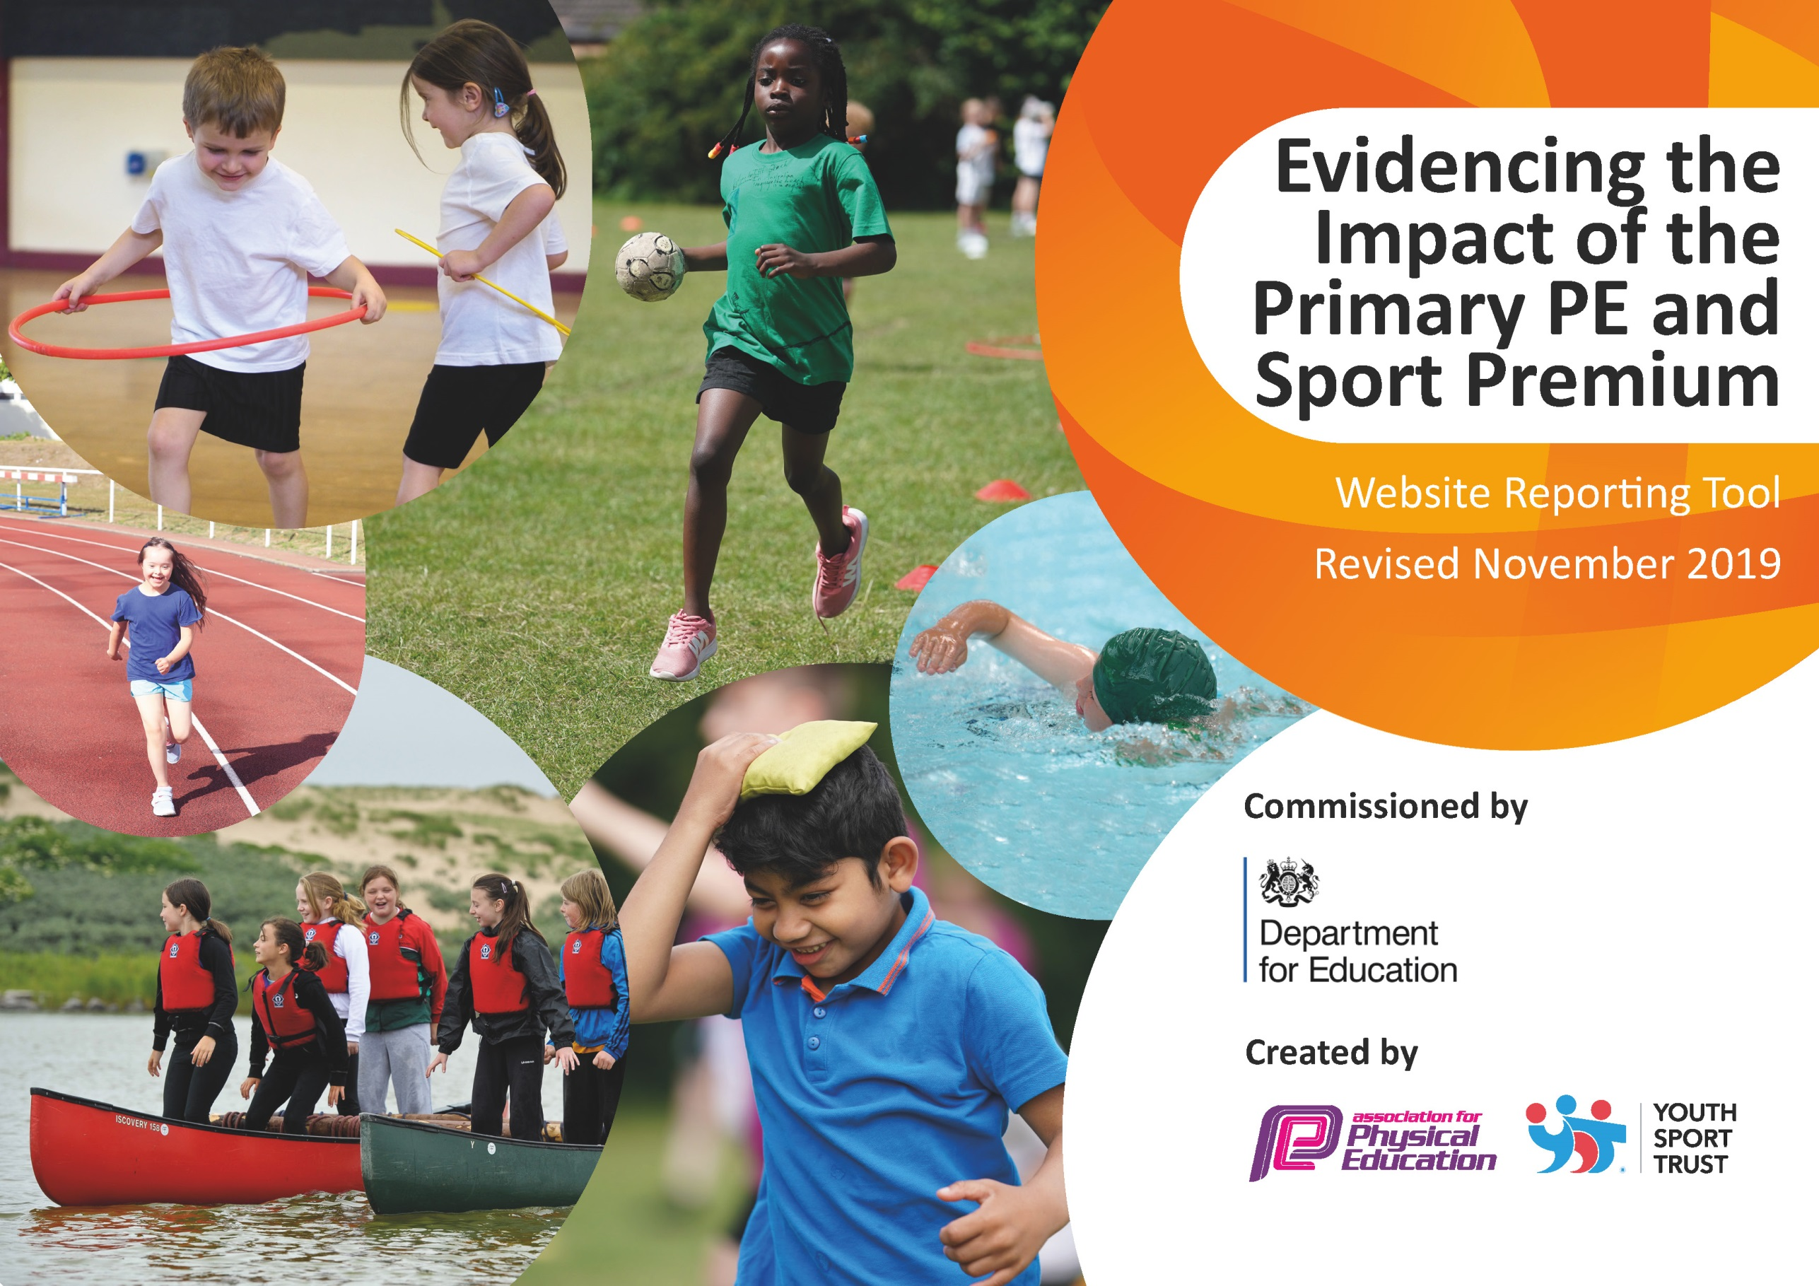
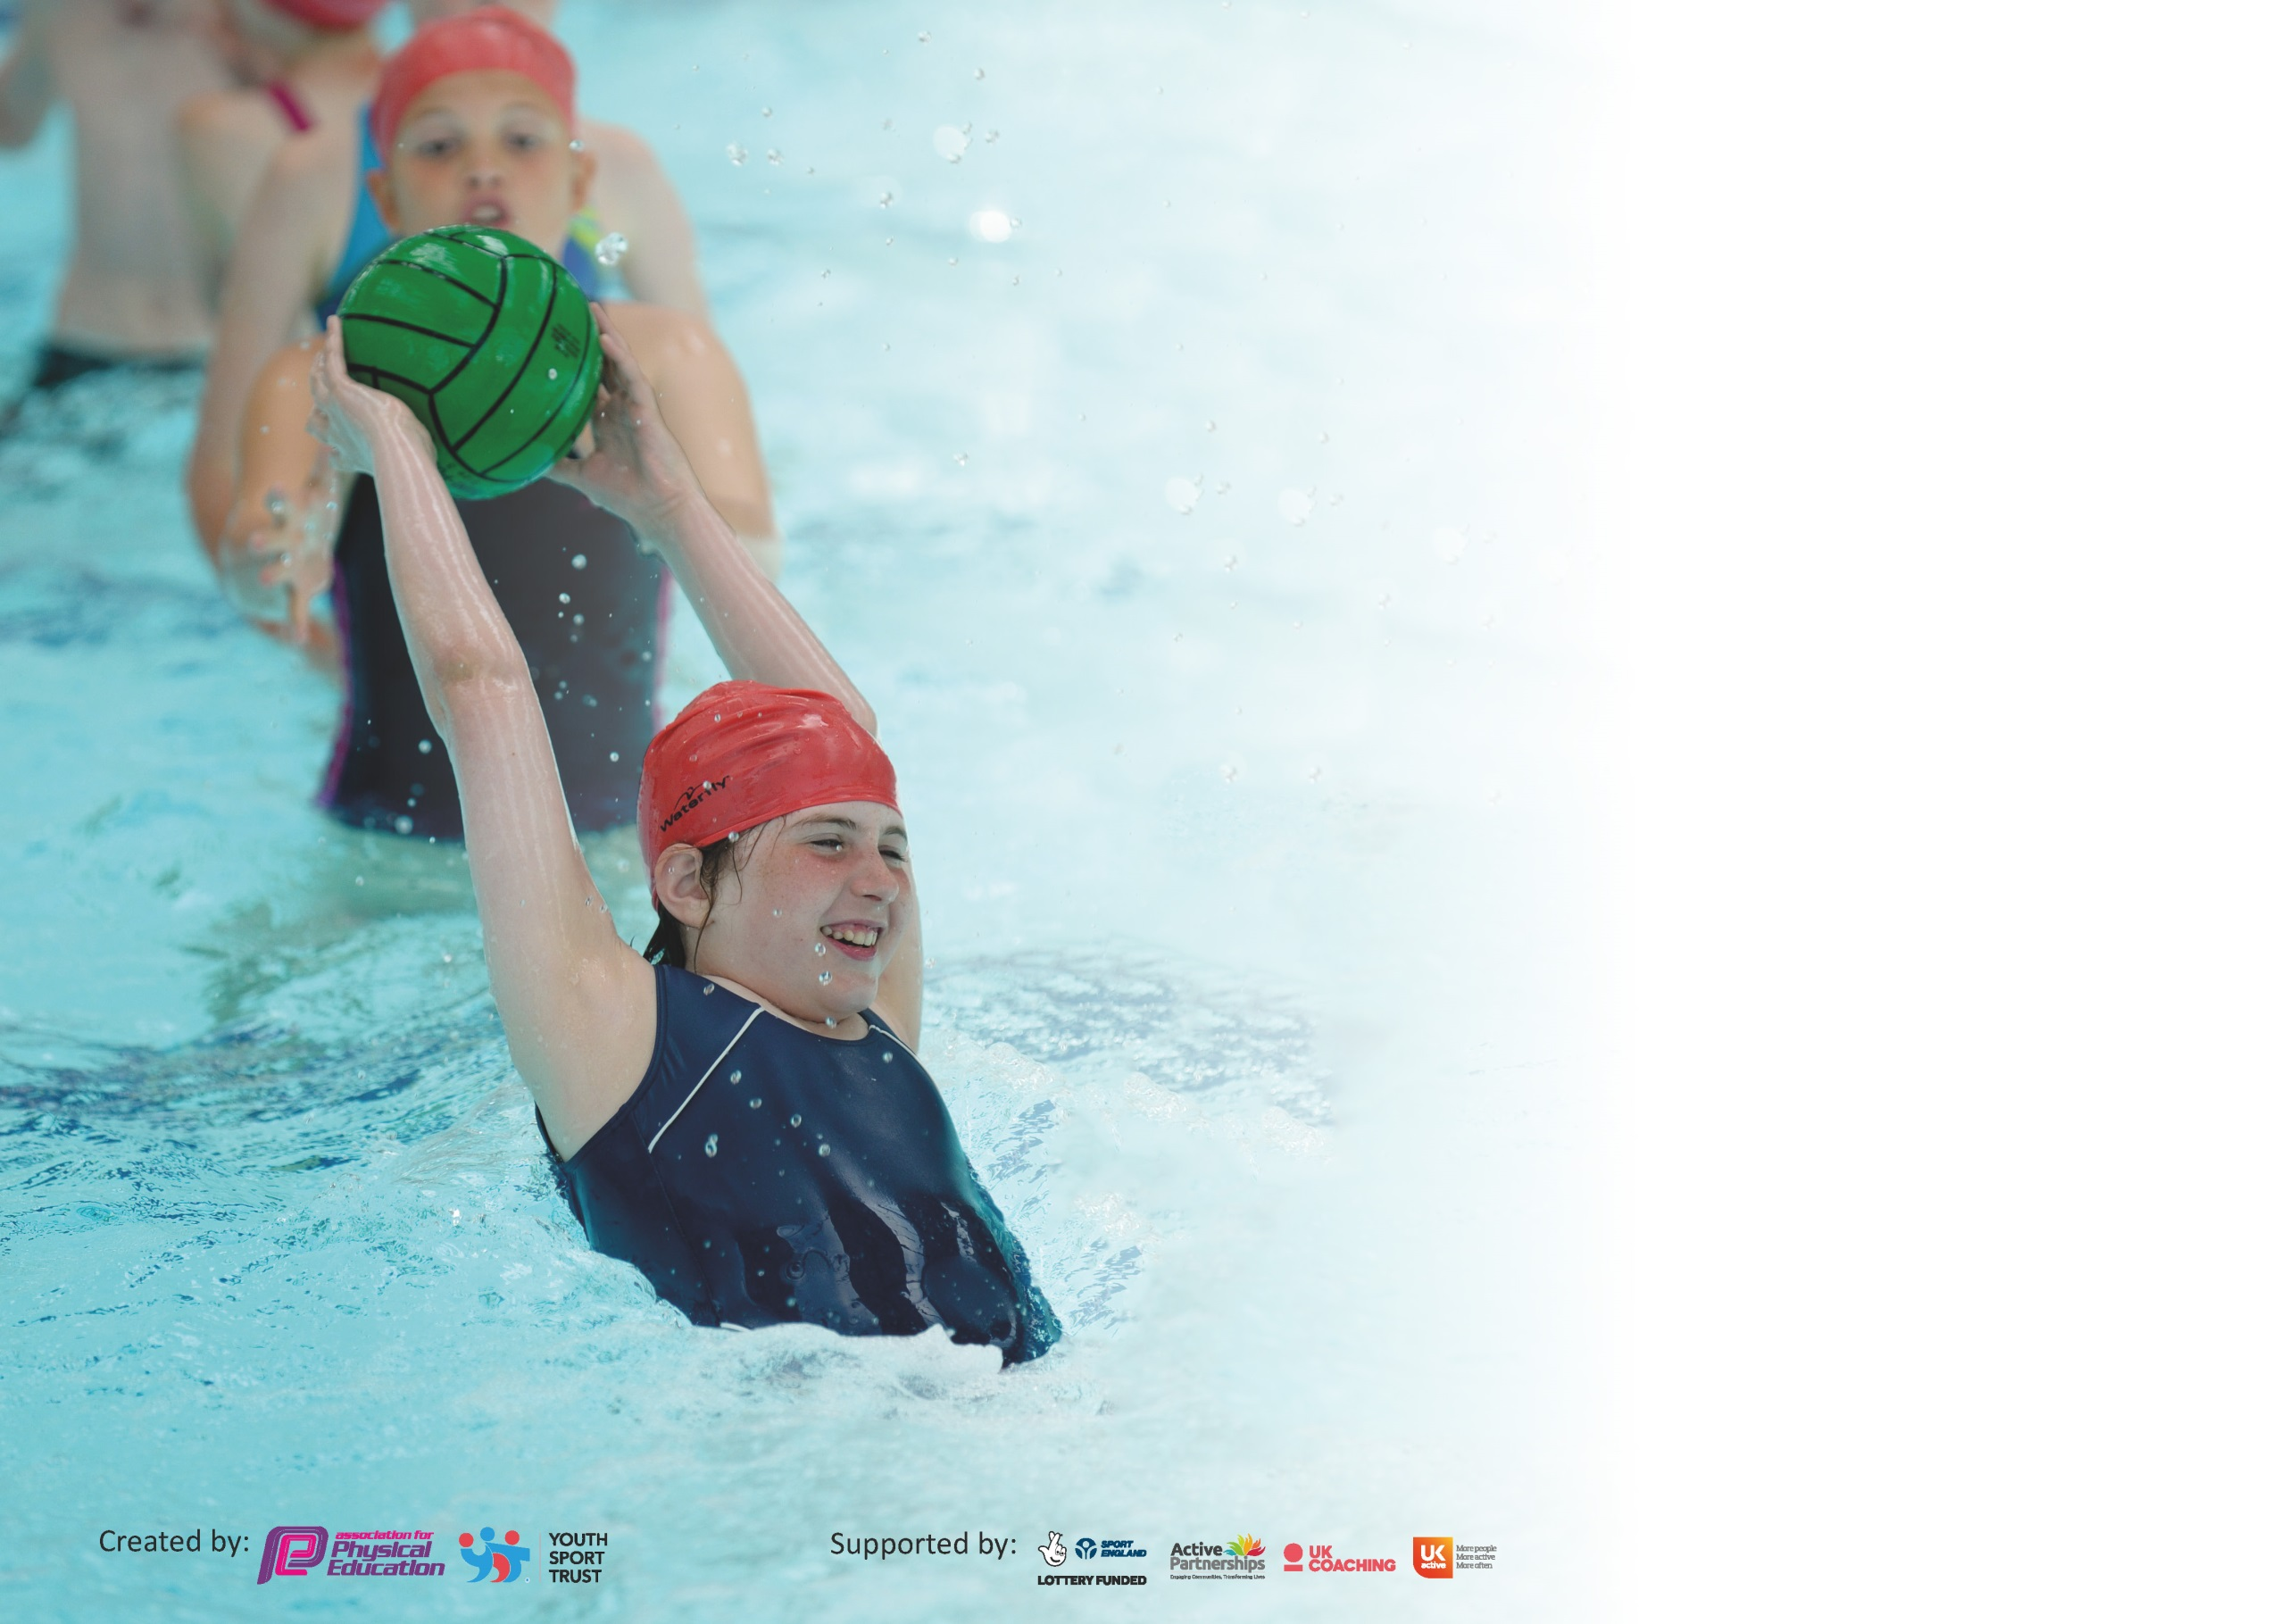

It is important that your grant is used effectively and based on school need. The Education Inspection Framework (Ofsted 2019 p64) makes clear there will be a focus on ‘whether leaders and those responsible for governors all understand their respective roles and perform these in a way that enhances the effectiveness of the school’.

Under the Quality of Education criteria (p41) inspectors consider the extent to which schools can articulate their curriculum (INTENT), construct their curriculum (IMPLEMENTATION) and demonstrate the outcomes which result (IMPACT).

To assist schools with common transferable language this template has been developed to utilise the same three headings which should make your plans easily transferable between working documents.

Schools must use the funding to make additional and sustainable improvements to the quality of Physical Education, School Sport and Physical Activity (PESSPA) they offer. This means that you should
use the Primary PE and Sport Premium to:

- Develop or add to the PESSPA activities that your school already offer
- Build capacity and capability within the school to ensure that improvements made now will benefit pupils joining the school in future years

Please visit gov.uk for the revised DfE guidance including the 5 key indicators across which schools should demonstrate an improvement. This document will help you to review your provision and to report your spend. DfE encourages schools to use this template as an effective way of meeting the reporting requirements of the Primary PE and Sport Premium.

We recommend you start by reflecting on the impact of current provision and reviewing the previous spend.

Schools are required to publish details of how they spend this funding as well as on the impact it has on pupils’ PE and sport participation and attainment by the end of the summer term or by 31st July 2020 at the latest.

We recommend regularly updating the table and publishing it on your website throughout the year. This evidences your ongoing self-evaluation of how you are using the funding to secure maximum, sustainable impact. Final copy must be posted on your website by the end of the academic year and no later than the 31st July 2020. To see an example of how to complete the table please click HERE.

Support for review and reflection - considering the 5 key indicators from DfE, what development needs are a priority for your setting and your pupils now and why? Use the space below to reflect on previous spend and key achievements and areas for development.

Key Indicators | Areas for further improvement:
Engage all pupils in regular physical activity – kick-starting healthy active lifestyles. | 1. Continue to ensure pupils have the opportunity to share and enthuse peers, within a range of sport- related  activities.  2. Signpost school community to a range of sport- related activities, specifically during holidays.  3. Raise further pupil self-esteem and enable them to develop broader skills to support others within an array of activities.  4. Encourage pupils and families to take an interest in healthy food choices and promote further enjoyment of physical activity.
Raise the profile of PE and sport across the school, as a tool for whole school improvement. | 1. Continue to raise awareness of sport and Olympics and Paralympics.  2. Continue to promote all aspects of physical activity so that all pupils are physically active, through PE lesson and at playtimes.  3. Continue to raise awareness of Mental Health. (HIGHER IMPORTANCE POST COVID-19).
Increase confidence, knowledge and skills of all staff in teaching PE and sport. | 1. All staff to be offered CPD and PE Co-ordinator to continue to advise and support.  2. PE Co-ordinator to lead staff meetings to discuss assessment and progression.  3. Look into purchasing GetSet4PE.
Develop a broader experience of a range of sports and activities offered to all pupils. | 1. Encourage 100% of the school community to participate in physical activity.  2. Develop further pupil participation in sport and ensuring pupils lead active and healthy lifestyles.  3. Bronze Ambassadors to lead three intra-house sports competitions.  4. To offer more clubs to KS1.
Increase participation in competitive sport. | 1. Continue to broaden the competition opportunities for all pupils.

Meeting national curriculum requirements for swimming and water safety.
What percentage of your current Year 6 cohort swim competently, confidently and proficiently over a distance of at least 25 metres?  N.B. Even though your pupils may swim in another year please report on their attainment on leaving  primary school at the end of the summer term 2020. | 64% when assessed in October 2019- they didn’t swim again due to Covid-19.
What percentage of your current Year 6 cohort use a range of strokes effectively [for example, front crawl, backstroke and breaststroke]? | 64% when assessed in October 2019- they didn’t swim again due to Covid-19.
What percentage of your current Year 6 cohort perform safe self-rescue in different water-based situations? | This was not assessed this year due to Covid-19.
Schools can choose to use the Primary PE and Sport Premium to provide additional provision for swimming but this must be for activity over and above the national curriculum requirements. Have you used it in this way? | No

Action Plan and Budget Tracking
Capture your intended annual spend against the 5 key indicators. Clarify the success criteria and evidence of impact that you intend to measure to evaluate for pupils today and for the future.

Academic Year: 2019/20 | Total fund allocated: £16,896 | Date Updated:
Key indicator 1: The engagement of all pupils in regular physical activity – Chief Medical Officer guidelines recommend that primary school pupils undertake at least 30 minutes of physical activity a day in school |  |  |  | Percentage of total allocation:
 |  |  |  | %
Intent | Implementation |  | Impact
Your school focus should be clear what you want the pupils to know and be able to do and about  what they need to learn and to  consolidate through practice: | Make sure your actions to achieve are linked to your intentions: | Funding allocated: | Evidence of impact: what do pupils now know and what can they now do? What has changed?: | Sustainability and suggested next steps:
Continue with Inspire+ membership and access the initiatives offered to build on the success of last year linked to healthy lifestyles, participation & sports opportunities.  Organise assemblies by Inspire+ ambassadors as good role models for the children – linked to healthy lifestyles and wellbeing.  Introduce playtime and lunchtime activities to promote more active minutes in school.  Continue to offer after- school clubs to all age ranges.  To support pupils’ mental health and build an understanding that physical exercise is an important part of becoming mentally resilient.  Participation tracker for club membership. | To encourage more sports opportunities for our pupils.  Pupils to be offered the opportunity to lead on health initiatives in school.  Visiting ambassadors to raise the profile of physical and mental wellbeing.  Train Year 5/6 pupils to deliver playground leader activities and games – timetabled throughout the week.  Sports Ambassador to lead ‘Daily Mile’ and track participation.  Co-ordinate use of Inspire+ coaches for club delivery and staff development for club delivery.  Liaise with Pastoral Lead to add physical exercise to children’s personal support plans where mental health is an identified difficulty.  To engage with local providers to deliver programs in the Spring Term. Liaise with Pastoral Lead to support particular children.  Use of participation tracker in school for tracking those involved in clubs, those with leadership opportunities and those less likely to engage in sport/physical activity. | £8000  Inspire+ membership  £500 (estimate) | Y 1-6 provided with a term of high-quality coaching.  Children accessing G and T programme.  All children attended assemblies.  All children now taking part in playground activities run by Year 6 Playground Leaders.  More variety of clubs offered.  More clubs for KS1.  Children are supported with Mental Health through physical activity.  KS1 23%  KS2 81%  (Figures are much lower than expected due to Covid-19.) | Next year’s 5/6 will need training.  CLUBS WILL NOT RESTART UNTIL JANUARY 2021 DUE TO COVID-19.  Long term good habits for children and understanding of how physical health can improve mental strength. Staff trained to deliver activities themselves in future years.
Key indicator 2: The profile of PESSPA being raised across the school as a tool for whole school improvement |  |  |  | Percentage of total allocation:
 |  |  |  | %
Intent | Implementation |  | Impact
Your school focus should be clear what you want the pupils to know and be able to do and about  what they need to learn and to  consolidate through practice: | Make sure your actions to achieve are linked to your intentions: | Funding allocated: | Evidence of impact: what do pupils now know and what can they now do? What has changed?: | Sustainability and suggested next steps:
Employ a Sports Apprentice.  Develop opportunities for pupil engagement with PESSPA throughout the school.  Devise pathways and incentives for pupil participation and development through PESSPA.  Weekly opportunities in assemblies for award giving linked to PESSPA achievements in school.  Raise profile of PESSPA with a sports board, website page and newsletter content.  Y5/6 to have First Aid training (inc. Mental Health) | Sports Apprentice to be employed and spend 1 day at college and 4 days in school. Sports Apprentice to work alongside staff supporting in lessons, lunchtime and after school clubs.  Encourage sporting opportunities for all and raise the profile of PESSPA as a toolkit for positive wellbeing and confidence.  Create a manageable plan for pupils’ engagement with PESSPA with links to a reward system for participation, leadership and development.  School staff to devise a plan for awarding certificates etc for PESSPA achievement. Daily Mile and Legacy Challenge achievements to be celebrated within these assemblies.  School to highlight importance of PESSPA through newsletter, website and sports notice board.  Y 5/6 to have a day of training looking at physical and mental first aid. | £6734  Using credits from Inspire+ | Sports Apprentice to apply their up to date knowledge to PE and Sport to assist with promoting it in school  All match and fixture results on website and noticeboard.  Success at competitions  New activities offered at breaks and as after-school clubs.  School vision, ethos linked to PE and School Sport and school reward system.  Celebration assemblies each term, Run a Mile awards, certificates, Legacy Challenge success, ambassadors.  PE notice board visible and accessible; website and newsletters updated, shared and celebrated.  Y 5/6 children will | Due to personal reasons, the Sports Apprentice left after one term.  DUE TO COVID-19, THIS TRAINING DID NOT TAKE PLACE-CREDITS ROLLED OVER TO NEXT YEAR.

Key indicator 3: Increased confidence, knowledge and skills of all staff in teaching PE and sport |  |  |  | Percentage of total allocation:
 |  |  |  | %
Intent | Implementation |  | Impact
Your school focus should be clear | Make sure your actions to | Funding | Evidence of impact: what do | Sustainability and suggested
what you want the pupils to know | achieve are linked to your | allocated: | pupils now know and what | next steps:
and be able to do and about | intentions: |  | can they now do? What has
what they need to learn and to |  |  | changed?:
consolidate through practice:
To provide CPD opportunities for staff so that pupils can benefit from expertise.  Access the Inspire+ Health check for any further support.  Inspire+ coaches to continue to work alongside staff.  PE Co-ordinator attended PE Conference in September 2019.  . | All staff have the opportunity to attend a range of PE related courses and work alongside specialist coaches to further expand knowledge and skills.  Coaches to upskill our teaching staff by working alongside them to deliver 6-week coaching sessions. |  | Increased subject knowledge across the subject leading to improved outcomes, sport, competitions.  PE Co-coordinator more confident, raises the quality, improved quality assurance.  Teaching staff upskilled their gymnastics knowledge.  Increased understanding of ‘picture’ of PE in the school.
Key indicator 4: Broader experience of a range of sports and activities offered to all pupils |  |  |  | Percentage of total allocation:
 |  |  |  | %
Intent | Implementation |  | Impact
Your school focus should be clear | Make sure your actions to | Funding | Evidence of impact: what do | Sustainability and suggested
what you want the pupils to know | achieve are linked to your | allocated: | pupils now know and what | next steps:
and be able to do and about | intentions: |  | can they now do? What has
what they need to learn and to |  |  | changed?:
consolidate through practice:
Additional achievements:  To offer a variety of clubs to children in both Key Stages.  Questionnaire for children and parents about sporting opportunities and what could be offered.  BAs to arrange intra-house sporting activities.  Those children identified as G&T to be offered enrichment sessions.  Year 6 weekend at PGL | Other clubs run by staff:  Football, multi-skills, cricket, rounders, handball and netball.  Inspire+ to help deliver a questionnaire to identify the needs of the children, parents and staff.  Children in KS1 and KS2 offered G&T sessions provided by Inspire+.  2 places are provided through Inspire+ membership. |  | Children offered a variety of after-school clubs – improved participation in KS1 but declined slightly in KS2.  Due to Covid-19, clubs did not take place as planned. | Have separate clubs for KS1 and KS2 next year to improve participation for KS2.  DUE TO COVID-19, THE Y6 PGL WEEKEND DID NOT TAKE PLACE- CREDITS ROLLED OVER.

Key indicator 5: Increased participation in competitive sport |  |  |  | Percentage of total allocation:
 |  |  |  | %
Intent | Implementation |  | Impact
Your school focus should be clear | Make sure your actions to | Funding | Evidence of impact: what do | Sustainability and suggested
what you want the pupils to know | achieve are linked to your | allocated: | pupils now know and what | next steps:
and be able to do and about | intentions: |  | can they now do? What has
what they need to learn and to |  |  | changed?:
consolidate through practice:
To support the SSCO School Games Organiser so that we as a school have access to top quality Inter-school competitions. | To liaise with SSCO to enable pupils to participate in a widening range of sporting competitions:  Continue to broaden/increase the competition opportunities for all pupils. | £750 | Children will attend competitions and results will be reported and tracked to ascertain what further support is required.  68% of KS2 have represented the school (84% last year).  Due to Covid-19, the number of available competitions was much lower so therefore fewer children participated. | Continue to ensure children are offered these opportunities- for some competitions, enter more than 1 team.

Signed off by
Head Teacher: | Ann Cook
Date: | 30/07/2020
Subject Leader: | HATTIE HUBBARD
Date: | 30/07/2020
Governor: | TONY SMITH
Date: | 30/07/2020

