Ropsley C of E Primary School
RSE (Relationships and Sex Education) policy



Adopted | Signed | Review | Equality  Impact  Assessment | Reviewed  against our  Vision | Amendments
March 2020 | Ann Cook (HT)  Fred Mann (FGB) | March 2020 | No | No
March 2022 | Ann Cook (HT)  Fred Mann (FGB) | Nov 2024 | No | Yes | Changed to include new curriculum map and resources from our scheme.  Changed review schedule to review annually.
Nov 2024 | Ann Cook (HT)  Fred Mann (FGB) | Nov 2025 | No | Yes | None

PSHE (Personal, Social, Health Education) and RSE (Relationships and Sex Education) policy

Aims
At Ropsley Church of England Primary School, we believe that PSHE helps to give pupils the knowledge, skills and understanding they need to lead confident, healthy, independent lives, in order to become informed, active and responsible citizens.
PSHE also flows through all other curriculum areas. Under the new guidance issued by the DfE, by September 2020, Relationships Education at primary school will be compulsory. We believe that, to be effective, RSE should always be taught within a broader PSHE education programme.
RSE enhances and is enhanced by learning related to topics including anti-bullying; keeping safe on and off line; keeping physically and mentally healthy, learning about drugs, alcohol and tobacco; and the development of skills and attributes such as communication skills, managing peer pressure, risk management, resilience and decision making.
The aims of PSHE and RSE at Ropsley are to:
- Promote the spiritual, moral, cultural, mental and physical development of all pupils
- Prepare pupils for the opportunities, responsibilities and experiences of later life
- Encourage pupils to value themselves and others
- Allow pupils to acknowledge and appreciate difference and diversity
- Teach pupils how to make informed choices
- Prepare pupils to be positive and active members of a democratic society
- Teach pupils to understand what constitutes a safe and healthy lifestyle
- Provide a framework in which sensitive discussions can take place
- Promote safety in forming and maintaining relationships
- Provide pupils with a toolkit for understanding and managing their emotions
- Provide pupils with the opportunities to consider issues which may affect their own lives and/or the lives of others
- Help pupils to identify the characteristics of healthy relationships, how relationships may affect mental and physical health; and how to stay safe online
- Prepare pupils for puberty, and give them an understanding of sexual development and the importance of health and hygiene
- Help pupils develop feelings of self-respect, confidence and empathy
- Create a positive culture around issues of sexuality and relationships
- Teach pupils the correct vocabulary to describe themselves and their bodies.

Statutory requirements
As a maintained primary school, we must provide relationships education to all pupils under section 34 of the Children and Social Work Act 2017.
We are not required to provide sex education, but we do need to teach the elements of sex education contained in the science curriculum.
In teaching RSE, we must have regard to guidance issued by the secretary of state, as outlined in section 403 of the Education Act 1996.
We must also have regard to our legal duties set out in:
- Sections 406 and 407 of the Education Act 1996
- Part 6, chapter 1 of the Equality Act 2010
- The Public Sector Equality Duty (as set out in section 149 of the Equality Act 2010). This duty requires public bodies to have due regard to the need to eliminate discrimination, advance equality of opportunity and foster good relations between different people when carrying out their activities

Policy development
This policy has been developed in consultation with Governors, staff, pupils and parents. The consultation and policy development process involved the following steps:
- Review – a specialist from within our collaborative partnership, pulled together all relevant information including relevant national and local guidance
- Staff consultation –school staff were given the opportunity to look at the policy and make recommendations.
- Pupil consultation – we investigated what exactly pupils want from their RSE and PSHE lessons via a pupil discussion
- Ratification – the policy was shared with and reviewed by the Full Governing Body.
Will now be circulated to parents for consultation.

Definition
RSE is part of lifelong learning about the emotional, social and physical aspects of growing up, relationships, sex, human sexuality and sexual health.
RSE, within PSHE, aims to give children and young people essential skills for building positive, enjoyable, respectful and non-exploitive relationships and the skills to stay safe both on and offline. It enables pupils to explore their own and other’s attitudes and values and builds their self-esteem and confidence to view their own sexuality positively. RSE is not about the promotion of sexual activity.

Curriculum
Our RSE curriculum is set out as per Appendix 2, but we may need to adapt it as and when necessary.
We have developed the curriculum in consultation with parents/carers, pupils and staff, and taking into account the age, developmental stage, needs and feelings of our pupils. If pupils ask questions outside the scope of this policy, teachers will respond in an appropriate manner so that pupils are fully informed and don’t seek answers online.
We will share all curriculum materials with parents and carers upon request.

Delivery
RSE is taught within the personal, social and health (PSHE) education curriculum. Some biological aspects of sex education are taught within the science curriculum. At Ropsley, we have developed our own PSHE scheme of work for Years 1-6, which incorporates all of the new RSE and Health requirements.
At Ropsley, we believe that pupils should be taught about the society in which they are growing up. These subjects are designed to foster respect for others and for difference and educate pupils about healthy relationships.
We believe that RSE should meet the needs of all pupils, whatever their developing sexuality or identity – this should include age-appropriate teaching about different types of relationships in the context of the law. Pupils should receive teaching on LGBT relationships, which is delivered at Ropsley, for example, through teaching about different types of family, including those with same sex parents.
Please see at Appendix 1 some of the class teaching strategies that may be used in PSHE lessons

Pupils with SEND
As far as is appropriate, pupils with special educational needs should follow the same PSHE education programme as all other students. Careful consideration is given concerning the level of differentiation needed, and in some cases the content or delivery will have to be adapted. Teachers and/or learning support assistants work with individual pupils where required, and if appropriate. It is not the school’s policy to withdraw pupils with special educational needs from PSHE education to catch up on other national curriculum subjects: these aspects of personal and social development are as important to all pupils as their academic achievement.

Roles and responsibilities
The governing body will approve the PSHE and RSE policy and hold the headteacher to account for its implementation.
The headteacher is responsible for ensuring that PSHE and RSE is taught consistently across the school, and for managing requests to withdraw pupils from components of RSE.
Staff
Staff are responsible for:
- Delivering PSHE and RSE in a sensitive way
- Modelling positive attitudes to RSE
- Monitoring progress
- Responding to the needs of individual pupils
- Responding appropriately to pupils whose parents wish them to be withdrawn from the [nonstatutory/non-science] components of sex education.
- Staff do not have the right to opt out of teaching PSHE or RSE.

Staff who have concerns about teaching RSE are encouraged to discuss this with the headteacher.
Pupils
Pupils are expected to engage fully in PSHE and, when discussing issues related to RSE, treat others with respect and sensitivity.

Inclusivity
We will teach about these topics in a manner that:
- Considers how a diverse range of pupils will relate to them
- Is sensitive to all pupils’ experiences
- During lessons, makes pupils feel:
  - Safe and supported
  - Able to engage with the key messages
We will also:
Make sure that pupils learn about these topics in an environment that’s appropriate for them, for example in:
  - A whole-class setting
  - Small groups or targeted sessions
  - 1-to-1 discussions
  - Digital formats

Give careful consideration to the level of differentiation needed

Use of resources
We will consider whether any resources we plan to use:
- Are aligned with the teaching requirements set out in the statutory RSE guidance
- Would support pupils in applying their knowledge in different contexts and settings
- Are age-appropriate, given the age, developmental stage and background of our pupils
- Are evidence-based and contain robust facts and statistics
- Fit into our curriculum plan
- Are from credible sources
- Are compatible with effective teaching approaches
- Are sensitive to pupils’ experiences and won’t provoke distress

Parents’ right to withdraw
The school understands the primary role in children’s relationships and sex education lies with parents and carers. We wish to build a positive and supportive relationship with the parents of children at our school through mutual understanding, trust and co-operation. In promoting this objective we:
- Make available online, via the school’s website, this PSHE and RSE Policy;
- Answer any questions that parents may have about the RSE/PSHE education of their child;
- Take seriously any issue that parents raise with teachers or governors about this policy or the arrangements for RSE/PSHE in the school;
- Inform parents about the best practice known with regard to RSE, so that the teaching in school supports the key messages that parents and carers give to children at home.

We believe that, through this mutual exchange of knowledge and information, children will benefit from being given consistent messages about their changing body and their increasing responsibilities.

Parents’ have the right to withdraw their child from sex education within RSE (other than sex education in the National Curriculum as part of science). There is no right to withdraw from Relationships Education at primary or secondary. We believe the contents of these subjects – such as family, friendship, safety (including online safety) – are important for all children to be taught.
Parents should be aware that schools are legally required to provide a broad, balanced curriculum.
Sex education topics can arise incidentally and overlap with relationships education lessons and it is not possible to withdraw pupils from these relatively limited and often unplanned discussions. Requests for withdrawal should be put in writing and addressed to the headteacher. A copy of withdrawal requests will be placed in the pupil’s educational record.
The headteacher will discuss the request with parents and take appropriate action.

Alternative work will be given to pupils who are withdrawn from these lessons.

Training
Staff are trained on the delivery of PSHE and RSE as requested or where our appraisal system suggests it is appropriate. The headteacher will also invite visitors from outside the school, such as school nurses or sexual health professionals, to provide support and training to staff teaching RSE.

Monitoring arrangements
The delivery of RSE is monitored by the Headteacher through: Lesson observations, learning walks, feedback from staff and children.
Pupils’ development in RSE is monitored by class teachers as part of our internal assessment systems.

- Appendix 1 (Strategies that may be used in PSHE)
- Appendix 2 Letter that will go home to Year 6 parents
- Appendix 3 Letter that will go home to Year 5 parents
- Appendix 4 Puberty leaflet for children in Years 5/6
- Appendix 5 Overview of the Scheme of Work • Appendix 6 Examples of the resources we will use.

Appendix 1
A variety of teaching and learning strategies are incorporated into our lessons. These include:
Agony Aunt / Uncle  Small groups that take on the role of an agony aunt or uncle, that responds to an imaginary problem or letter. | Ideas Gathering  Children offer suggestions to an idea or concept. All suggestions are recorded without challenge or discussion. Material can then be used for assessment of knowledge and displaying myths around other things. | Buzz Group  Small groups of 3-4. Groups are asked to discuss a scenario or dilemma for a short time. Each group then feeds back to the class their ideas. | Circle Time  A mechanism for structured discussion, where all learners sit in a circle to discuss feelings, emotions and learning.
Continuum  An imaginary line is drawn down the classroom. One end represents agree and the other represents disagree. Statements relating to a specific area are read out and children have to decide whether they agree or disagree and discuss why. | Diamond 9 / Pyramid  Small groups are given cards, each with a statement relating to a particular discussion. Each group arranges their cards in order of importance in a diamond or pyramid shape. | Draw and write  Pupils are asked to draw and write in response to a specific question to find out their level of previous knowledge. | Question Box  A way of encouraging children to ask questions about difficult topics anonymously. A sealed box with a letter box is placed where children can easily access it. Children ‘post’ their questions, which teachers can then answer in class.
Mind mapping  Write an issue or problem in the middle of a page and branch out from the centre with the main themes and then continue to branch out each main theme. | Posters / Collage  A way of illustrating a theme or a topic, through drawing or IT, celebrating the children’s work and letting other views be seen. | Drawing  A way of illustrating a theme or idea. | Role Play  (Includes toys / puppet) Pupils / toys take on the role of another person and act out a scenario.
Rounds  All pupils are invited to express a view or opinion about a particular situation, usually at the end or the beginning of a session. | Scenarios  Children reflect on all of the choices and discuss possible consequences of the characters in the scenario. They then discuss how things could have gone differently. | Snowballing  Pupils work alone for a few minutes, listing ideas related to a task. They then form pairs and share views. The pairs then double up and share their views and so on. | Time lines  Children mark on a line, different things depending on the topic. Eg things they could do at different times of their life.
Use of Photographs and pictures  Photographs from magazines or other media sources or pictures from picture packs are used to discuss body language, emotions, and stereotyping. | Use of Literature  A variety of literacy is used to help children to identify with situations, deal with sensitive issues and develop their use of language in regards to feelings and relationships. | Video / DVD / Media A way of illustrating or highlighting visually a specific theme or topic. | Working in Pairs  Two children discussing their views and opinions, ready to feedback to a larger group – whether it be to a larger group or the whole class.

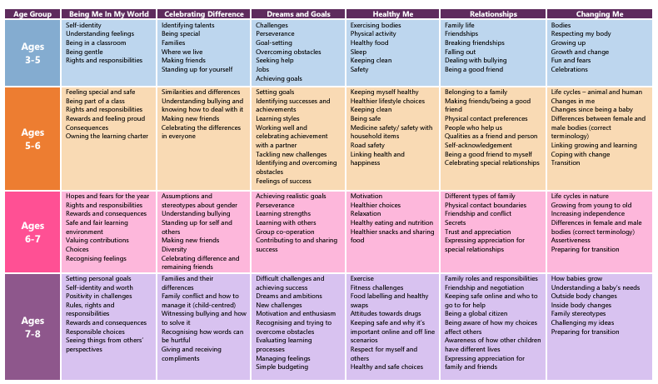
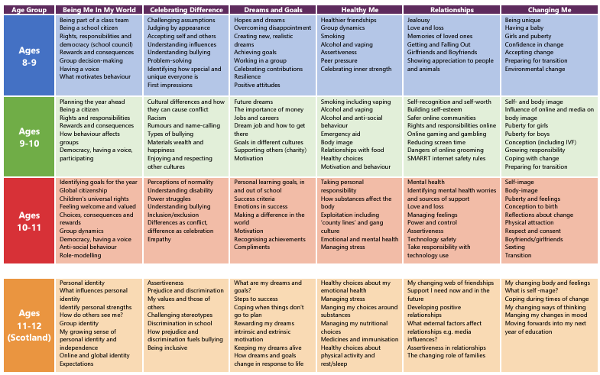
Appendix 3 Year 6 ONLY

Dear Parents,
On the ___________________, your son’s/daughter’s class will begin a Relationships and Sex Education Unit.

The School-based unit is not a substitute for what you teach in your home, but it can play an important role in preparing your children for their future. It is our belief that you, as parents, play the most important role in the formation of your children’s values and behaviours related to human growth and development.

The purpose of this letter is to inform you of the topics that will be covered and to provide you with the opportunity to speak with me prior to starting this unit of work.

As you are aware children are taught about puberty during Year 5 at Ropsley. This unit of work builds on and recaps on that knowledge followed by two lessons which will explore human reproduction.

Pupils learn about human reproduction in the context of the human lifecycle.
- Self-image Body-image Puberty and feelings
- Conception to birth
- Reflections about change
- Physical attraction
- Respect and consent
- Boyfriends/girlfriends Sexting
- Preparing for change

This will of course be taught in an age appropriate and sensitive way. We use strategies that support pupils in asking questions without embarrassment and staff are trained and experienced in dealing carefully with the matters the children raise.
You can find further details and examples of the resources we will use on our website within the PHSE and RSE Pages.
Although, there is no right to withdraw pupils from these lessons we are keen to work in partnership with parents and if you have concerns, please feel free to pop and see me.

Appendix 4 Year 5 ONLY

Dear Parents
On the ___________________, your son’s/daughter’s class will begin a PSHE Unit of work that looks at Puberty.

The School-based unit is not a substitute for what you teach in your home, but it can play an important role in preparing your children for their future. It is our belief that you, as parents, play the most important role in the formation of your children’s values and behaviours related to human growth and development.

The following objectives will be taught:
- Self- and body image Influence of online and media on body image
- Puberty for girls Puberty for boys
- Conception (including IVF) Growing responsibility
- Coping with change
- Preparing for the changes
- Girls will be taught about how to manage their periods and the range of sanitary protection open to them including what to do if it happens in school.

This will of course be taught in an age appropriate and sensitive way. We use strategies that support pupils in asking questions without embarrassment and staff are trained and experienced in dealing with carefully with the matters the children raise.

You can find further details and examples of the resources we will use on our website within the PHSE and RSE Policy this includes the guidance leaflet we will be giving to pupils.

Although, there is no right to withdraw pupils from these lessons we are keen to work in partnership with parents and if you have concerns please feel free to pop and see me.
Appendix 6 Examples of Resources

EYFS Body parts labelling

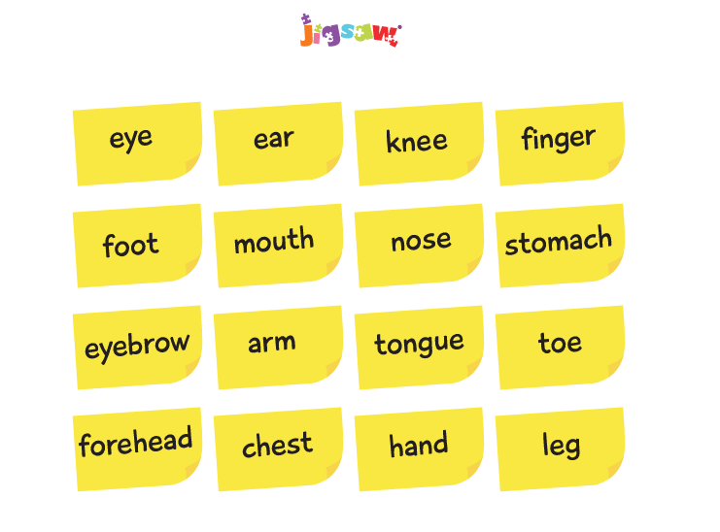

Year 1 Identifying people who help us.

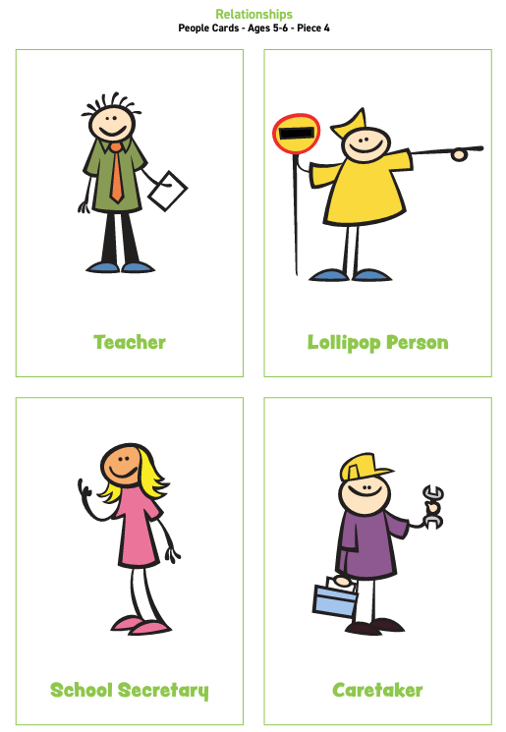

Year 2 Celebrating difference

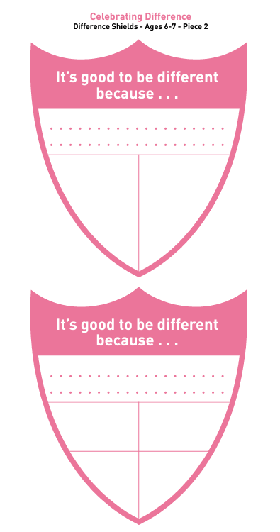

Year 3 Staying safe online

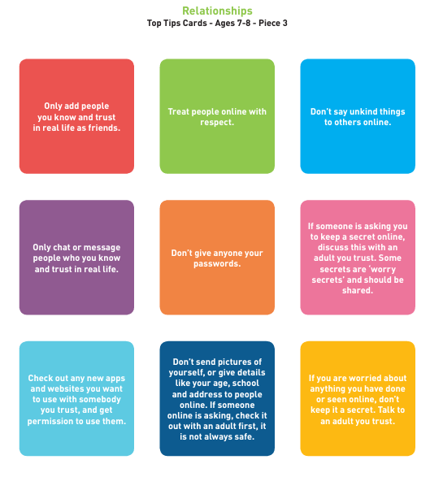

Year 4 Overcoming disappointment

Scenario cards

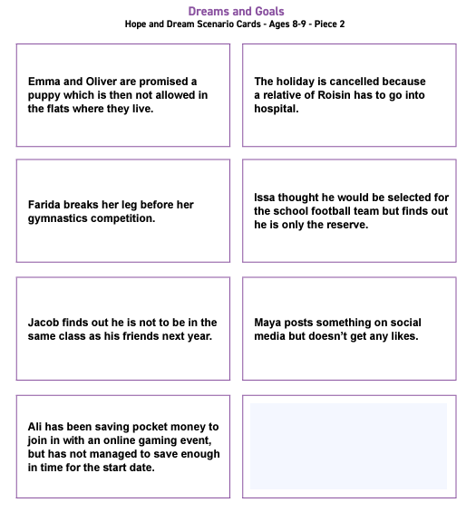

Year 5 Puberty for girls

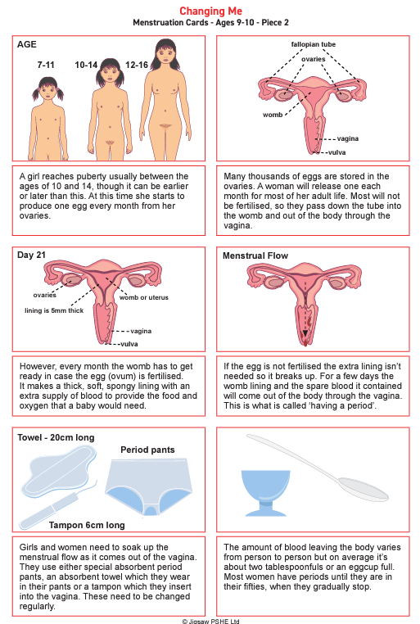

Year 5 Puberty for boys

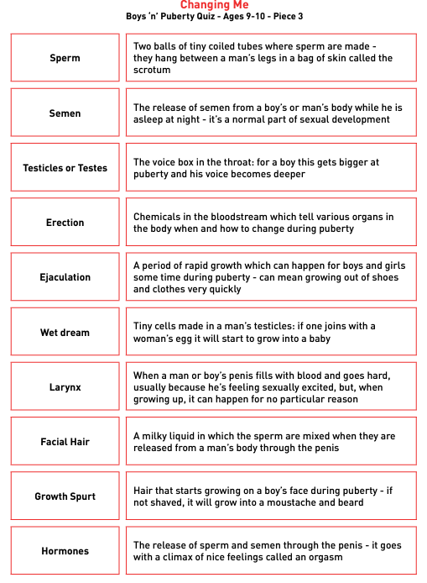
Year 6 Preparing for change

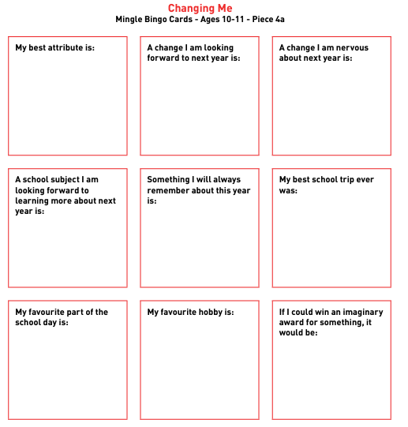


Policy/Vision impact review
In God's image, we strive and shine: with happy hearts and inspired minds
Our Vision
Our vision is to be a caring, happy and inclusive church school that is at the heart of our community. We strive to provide an excellent education which develops a life-long love of learning in a global context. We see all members of our school family as valued and precious in the eyes of God. We seek to do this through an innovative, engaging and inspiring curriculum that encourages us all to flourish.

Policy Name | RSE Policy
Completed by | Ann Cook
Date | November 2024
How will this policy affect ALL members of our school family?
Pupils, parents, staff, governors, members of the community, outside agencies, charities (global, national, and local.)
Impact
Pupils | Through our PSHE and RSE curriculum, pupils gain essential knowledge and skills that help them lead confident, healthy, and fulfilling lives. This policy nurtures our values by creating a caring and inclusive environment where every child feels valued, can build self-respect, and learns empathy for others. By developing their understanding of healthy relationships and personal well-being, we encourage pupils to flourish as informed and responsible citizens, building a foundation for a lifelong love of learning.
Parents | This policy provides parents with confidence that their children are learning in a supportive, values-driven environment that prioritizes their well-being and development. By integrating PSHE and RSE across the curriculum, we ensure that parents can trust the school to provide a holistic education that values each child and promotes respect, empathy, and informed decision-making. In partnership with parents, we work to cultivate an environment where every child is equipped to make positive choices.
Staff | The PSHE and RSE policy provides staff with a supportive framework to engage pupils in meaningful discussions on critical life skills and personal development, aligning with our vision of a caring and inclusive school. It empowers teachers to deliver a curriculum that is both innovative and engaging, fostering pupils' resilience, confidence, and well-being. This policy enhances the school culture, where staff play an active role in nurturing each child’s spiritual, moral, and emotional growth in a way that honors their unique, God-given worth.
Governors | This policy allows governors to support the school’s vision of providing an inclusive, supportive education that prepares pupils for life beyond the classroom. By promoting PSHE and RSE as essential components of personal and academic growth, governors help ensure that the curriculum fosters responsible, active citizenship in a democratic society. This aligns with our vision to be a school that values each child, ensuring they are seen as precious and encouraged to flourish.
Community | By implementing this policy, the school strengthens its commitment to the wider community, preparing pupils to be respectful, informed, and active citizens who value diversity and inclusivity. The PSHE and RSE curriculum fosters a caring, empathetic outlook, encouraging pupils to develop the skills needed to contribute positively to society. Through this commitment, the school reinforces its role at the heart of the community, dedicated to nurturing children who respect themselves, others, and the world around them
Are any changes to the policy recommended?
No

