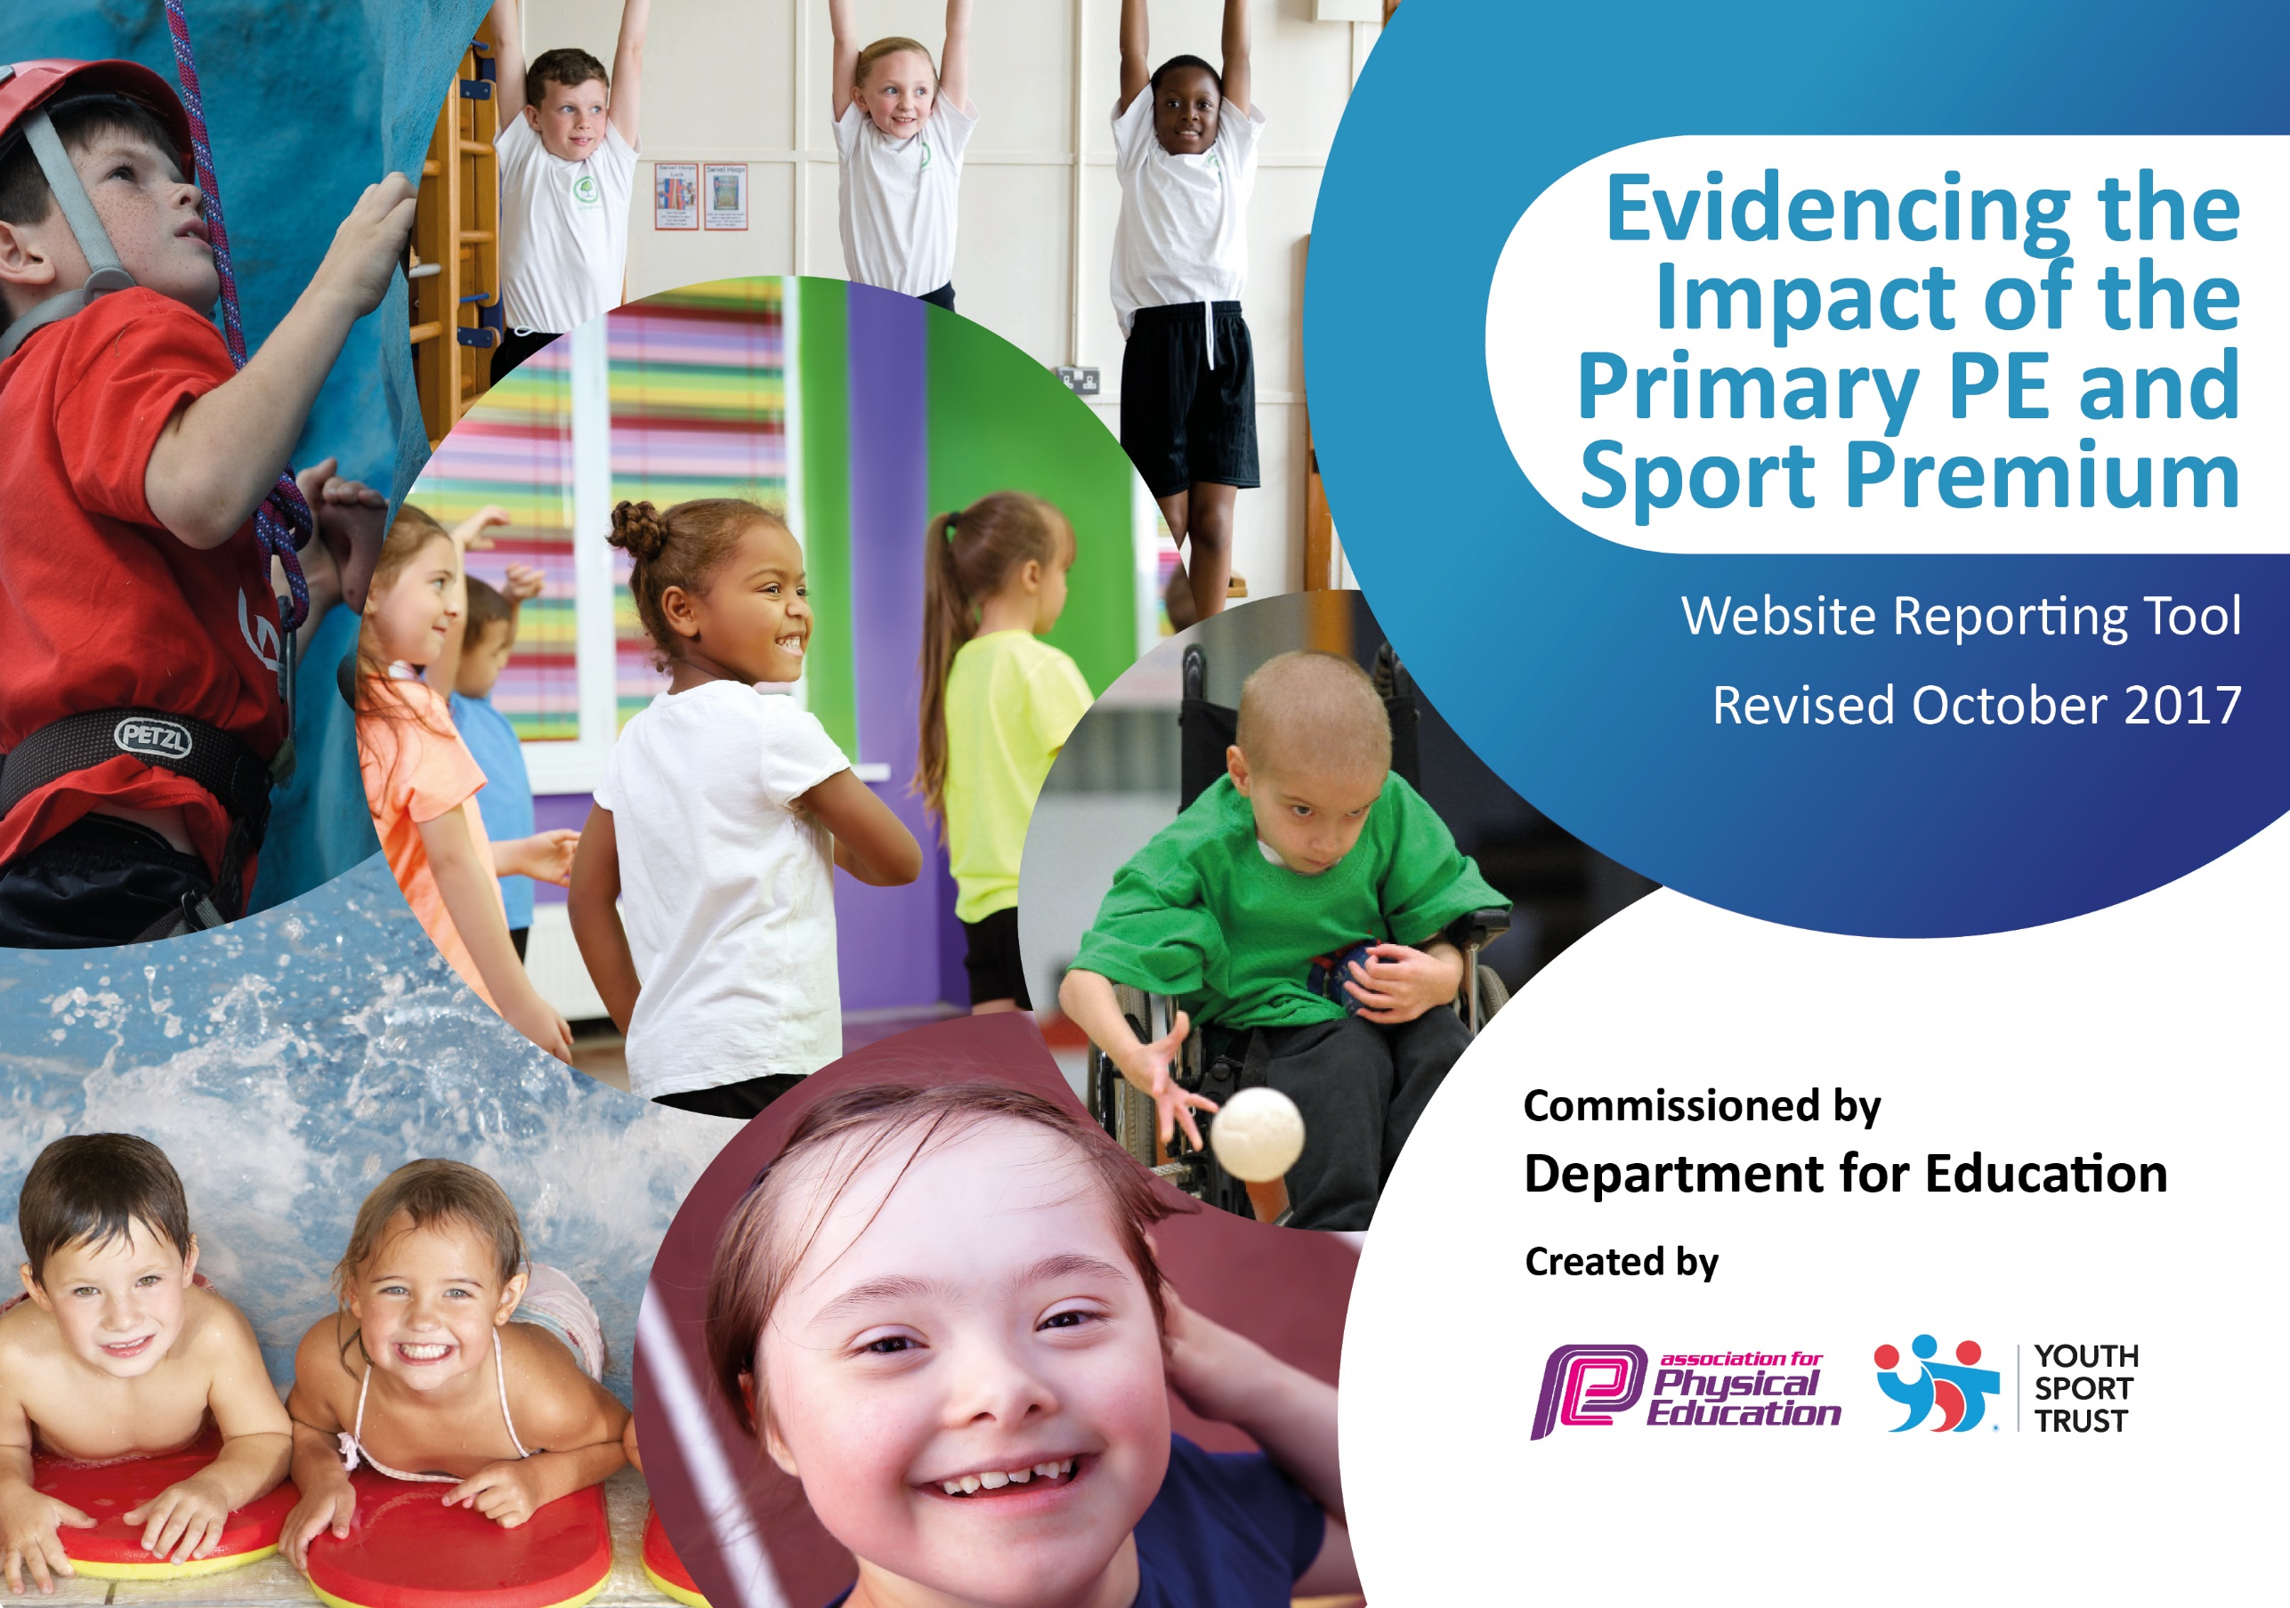

Schools must use the funding to make additional and sustainable improvements to the quality of PE and sport they offer. This means that you should use the Primary PE and Sport Premium to:

- develop or add to the PE and sport activities that your school already offers
- build capacity and capability within the school to ensure that improvements made now will benefit pupils joining the school in future years

Please visit gov.uk for the revised DfE guidance including the 5 key indicators across which schools should demonstrate an improvement. This document will help you to review your provision and to report your spend. DfE encourages schools to use this template as an effective way of meeting the reporting requirements of the Primary PE and Sport Premium.

We recommend you start by reflecting on the impact of current provision and reviewing the previous spend.
Under the Ofsted Schools Inspection Framework, inspectors will assess how effectively leaders use
the Primary PE and Sport Premium and measure its impact on outcomes for pupils, and how effectively governors hold them to account
for this.

Schools are required to publish details of how they spend this funding as well as on the impact it has on pupils’ PE
and sport participation and attainment.
We recommend regularly updating the table and
publishing it on your website as evidence
of your ongoing review into how you are using the money
to secure maximum, sustainable impact. To see an example of how to complete the table please click HERE.

Support for review and reflection - considering the 5 key indicators from DfE, what development needs are a priority for your setting and your students now and why? Use the space below to reflect on previous spend, identify current need and priorities for the future.

No data available from previous academic year.

Key Indicators | Areas for further improvement and baseline evidence of need:
Engage all pupils in regular physical activity – kick-starting healthy active lifestyles. | 1. Continue to ensure pupils have the opportunity to share and enthuse peers, within a range of sport related  activities.  2. Signpost school community to a range of sport related activities, through holidays.  3. Raise further pupil self-esteem and enable them to develop broader skills to support others within an array of activities.  4. Encourage pupils and families to take an interest in healthy food choices and promote further enjoyment of physical activity.
Raise the profile of PE and sport across the school, as a tool for whole school improvement. | 1. Continue to raise awareness of sport and Olympics and Paralympics.  2. Continue to promote all aspects of physical activity so that all pupils are physically active, through PE lesson and at playtimes.
Increase confidence, knowledge and skills of all staff in teaching PE and sport. | 1. All staff to be offered CPD and PE Co-ordinator to continue to advise and support.  2. PE Co-ordinator to lead staff meetings to discuss assessment and progression.
Develop a broader experience of a range of sports and activities offered to all pupils. | 1. Encourage 100% of the school community to participate in physical activity.  2. Develop further pupil participation in sport and ensuring pupils lead active and healthy lifestyles.  3. Bronze Ambassadors and Sports Apprentice to lead three intra-house sports competitions.  4. To offer more clubs to KS1.
Increase participation in competitive sport. | 1. Continue to broaden the competition opportunities for all pupils.

Meeting national curriculum requirements for swimming and water safety | Please complete all of the below:
What percentage of your Year 6 pupils could swim competently, confidently and proficiently over a distance of at least 25 metres when they left your primary school at the end of last academic year? | 61%
What percentage of your Year 6 pupils could use a range of strokes effectively [for example, front crawl, backstroke and breaststroke] when they left your primary school at the end of last academic year? | 61%
What percentage of your Year 6 pupils could perform safe self-rescue in different water-based situations when they left your primary school at the end of last academic year? | Data unavailable- data present for next academic year.
Schools can choose to use the Primary PE and Sport Premium to provide additional provision for swimming but this must be for activity over and above the national curriculum requirements. Have you used it in this way? | No

Action Plan and Budget Tracking
Capture your intended annual spend against the 5 key indicators. Clarify the success criteria and evidence of impact that you intend to measure to evaluate for students today and for the future.

Academic Year: 2017/18 | Total fund allocated: £16,950 | Date Updated: March 2018
Key indicator 1: The engagement of all pupils in regular physical activity – Chief Medical Officer guidelines recommend that primary school children undertake at least 30 minutes of physical activity a day in school |  |  |  | Percentage of total allocation:
 |  |  |  | %
School focus with clarity on intended impact on pupils: | Actions to achieve: | Funding allocated: | Evidence and impact: | Sustainability and suggested next steps:
Continue with Inspire+ membership and access the initiatives offered to build on the success of last year linked to healthy lifestyles, participation & sports opportunities.  Organise assemblies by Inspire+ ambassadors as good role models for the children – linked to healthy lifestyles and wellbeing.  Introduce playtime and lunchtime activities to promote more active minutes in school.  Continue to offer after school clubs to all age ranges.  Participation tracker for club membership.  Purchase Maths of the Day (MOTD) | To deliver the Legacy Challenge and promote health and fitness.  To encourage more sports opportunities for our pupils.  Pupils to be offered the opportunity to lead on health initiatives in school.  Visiting ambassadors to raise the profile of physical and mental wellbeing.  Train Year 5/6 pupils to deliver playground leader activities and games – timetabled throughout the week.  Sports Ambassador to lead ‘Daily Mile’ and track participation.  Co-ordinate use of Inspire+ coaches for club delivery and staff development for club delivery.  Use of participation tracker in school for tracking those involved in clubs, those with leadership opportunities and those less likely to engage in sport/physical activity.  All staff given MOTD log-ins, enabling them to lead Active Maths lessons.  Sports Apprentice uses MOTD with children in after school clubs weekly.  KS1 teacher to run a MOTD club in the Summer Term. | £8000  Inspire+ membership  £395 | All children participating in and accessing Legacy Challenge.  Children accessing G and T programme.  All children attended assemblies.  All children now taking part in playground activities.  Target by July-100% of all children taking part in at least one afterschool club.  March- KS1 59%  LKS2 77%  UKS2 96%
Key indicator 2: The profile of PE and sport being raised across the school as a tool for whole school improvement |  |  |  | Percentage of total allocation:
 |  |  |  | %
School focus with clarity on intended impact on pupils: | Actions to achieve: | Funding allocated: | Evidence and impact: | Sustainability and suggested next steps:
Employ a Sports Apprentice.  Develop opportunities for pupil engagement with PE and sport throughout the school.  Devise pathways and incentives for pupil participation and development through sport and physical activity.  Monthly/termly opportunities in assemblies for award giving linked to PE and physical activity achievements in school.  Raise profile of PE and Physical Activity with a sports board, website page and newsletter content. | Sports Apprentice to be employed and spend 1 day at college and 4 days in school. Sports Apprentice to work alongside staff supporting in lessons, lunchtime and after school clubs.  Encourage sporting opportunities for all and raise the profile of PE and sport as a toolkit for positive wellbeing and confidence.  Create a manageable plan for pupils’ engagement with physical activity with links to a reward system for participation, leadership and development.  School staff to devise a plan for awarding certificates etc for PE/PA achievement. Daily Mile and Legacy Challenge achievements to be celebrated within these assemblies.  School to highlight importance of PE through newsletter, website and sports notice board. | £6734  Inspire+ membership | Sports Apprentice to apply their up to date knowledge to PE and Sport to assist with promoting it in school.  All match and fixture results on website.  Success at competitions  New activities offered?  School vision, ethos linked to PE and School Sport and school reward system.  Celebration assemblies each term, Run a Mile awards, certificates and medals, Legacy Challenge success, ambassadors.  PE notice board visible and accessible; website and newsletters updated, shared and celebrated.

Key indicator 3: Increased confidence, knowledge and skills of all staff in teaching PE and sport |  |  |  | Percentage of total allocation:
 |  |  |  | %
School focus with clarity on intended  impact on pupils: | Actions to achieve: | Funding  allocated: | Evidence and impact: | Sustainability and suggested  next steps:
To provide CPD opportunities for staff so that pupils can benefit from expertise.  Access the Inspire+ Health check for any further support.  Inspire+ coaches to continue to work alongside staff.  PE Co-ordinator and Sports Apprentice attended PE Conference in September 2017.  Sports Apprentice offered staff CPD. | All staff have the opportunity to attend a range of PE related courses and work alongside specialist coaches to further expand knowledge and skills.  Coaches to upskill our teaching staff by working alongside them to deliver 6 week coaching sessions.  Sports Apprentice given the opportunity to attend CPD courses and sent on the ASA Level 2 Swimming Course. | Inspire+ membership  £250 | Increased subject knowledge across the subject leading to improved outcomes, sport, competitions.  Subject leader PE Co-coordinator more confident, raises the quality, improved quality assurance  Effective, timely and purposeful assessment, with all teaching staff understanding where their strengths lie and areas of improvement.  Increased understanding of ‘picture’ of PE in the school.
Key indicator 4: Broader experience of a range of sports and activities offered to all pupils |  |  |  | Percentage of total allocation:
 |  |  |  | %
School focus with clarity on intended  impact on pupils: | Actions to achieve: | Funding  allocated: | Evidence and impact: | Sustainability and suggested  next steps:
To offer a variety of clubs to children in both Key Stages.  Questionnaire for children and parents about sporting opportunities and what could be offered.  BA and Sports Apprentice to arrange intra-house sporting activities.  Those children identified as G&T to be offered enrichment sessions. | To fund (if required) specialist coaches to deliver Football, Tag Rugby, KWIK Cricket, Netball, Tennis, Athletics and Dance clubs. 1. Develop further pupil participation in sport and ensuring pupils lead active and healthy lifestyles.  2. Encourage 100% of the school community to participate in physical activity.  Inspire+ to help deliver a questionnaire to identify the needs of the children, parents and staff.  Children in KS1 and KS2 offered G&T sessions provided by Inspire+. | Inspire+ membership | Boxercise offered to Year 5/6.  Multi-skills offered to EYFS.  These six week sessions were offered by Premier Education without charge.  PE Co-ordinator to arrange sessions for next academic year. (£800 set aside for these sessions.)
Key indicator 5: Increased participation in competitive sport |  |  |  | Percentage of total allocation:
 |  |  |  | %
School focus with clarity on intended  impact on pupils: | Actions to achieve: | Funding  allocated: | Evidence and impact: | Sustainability and suggested  next steps:
To support the SSCO School Games Organiser so that we as a school have access to top quality Inter-school competitions.  To attend the Sports Stars events throughout the year, run by The Charles Read Academy.  To offer Year 2 children the opportunity to attend the Festival of Sport. | To liaise with SSCO to enable pupils to participate in a widening range of sporting competitions:  1. Continue to broaden/increase the competition opportunities for all pupils.  2. Introduce a newly devised tracking systems to monitor pupil uptake and support further analysis.  Ensure children attend all 8 events throughout the year. (We won the overall competition in 2016/17.)  Children in Year 2 will attend the Festival, aimed at giving them opportunities to try out new and existing sports. | £750 | Children will attend competitions and results will be reported and tracked to ascertain what further support is required.  March- 76% of KS2 have represented the school.  Children to retain their title competing against 6 other local primary schools all within Charles Read Academy’s catchment area; thus encouraging new friendships.

Other indicators – Swimming

Year 6 data prepared in readiness for 2018/19-

Percentage of students who are able to swim competently, confidently and proficiently over a distance of 25m- 90%

Percentage of students able to use a range of strokes effectively – 90%

Percentage of students able to perform self-rescue in different water based situations – 90%

