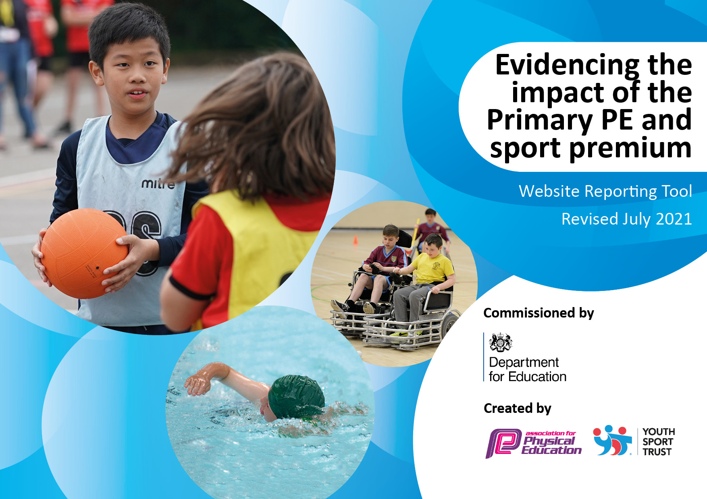
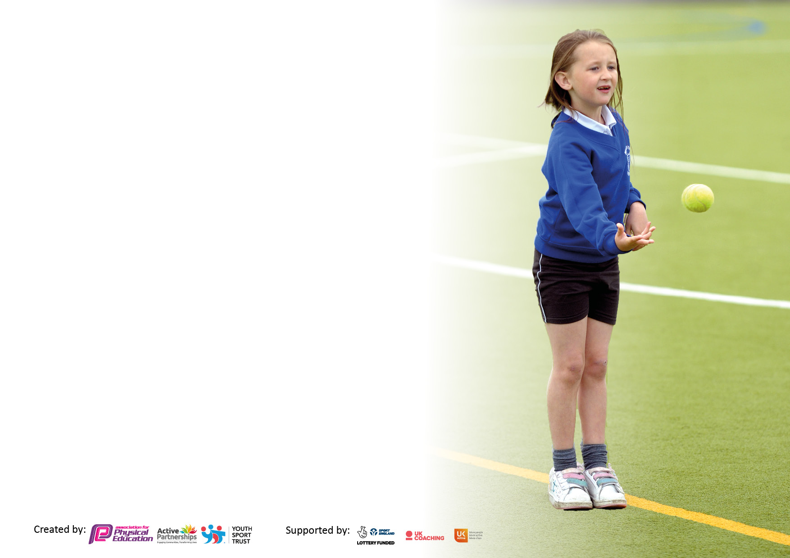

It is important that your grant is used effectively and based on school need. The Education Inspection Framework makes clear there will be a focus on ‘whether leaders and those responsible for governors all understand their respective roles and perform these in a way that enhances the effectiveness of the school’.

Under the Quality of Education Ofsted inspectors consider:
Intent - Curriculum design, coverage and appropriateness
Implementation - Curriculum delivery, Teaching (pedagogy) and Assessment
Impact - Attainment and progress

To assist schools with common transferable language this template has been developed to utilise the same three headings which should make your plans easily transferable between working documents.

Schools must use the funding to make additional and sustainable improvements to the quality of Physical Education, School Sport and Physical Activity (PESSPA) they offer. This means that you should use the Primary PE and sport premium to:

- Develop or add to the PESSPA activities that your school already offer
- Build capacity and capability within the school to ensure that improvements made now will benefit pupils joining the school in future years
- The Primary PE and sport premium should not be used to fund capital spend projects; the school’s budget should fund these.

Pleasevisitgov.ukfortherevisedDfEguidanceincludingthe5keyindicatorsacrosswhichschoolsshoulddemonstrate animprovement.Thisdocumentwillhelpyoutoreviewyourprovisionandtoreportyourspend.DfEencouragesschools to use this template as an effective way of meeting the reporting requirements of the Primary PE and sport premium.

We recommend you start by reflecting on the impact of current provision and reviewing the previous spend.

Schools are required to publish details of how they spend this funding, including any under-spend from 2019/2020, as well as on the impact it has on pupils’ PE and sport participation and attainment. All funding must be spent by 31st July 2022.

We recommend regularly updating the table and publishing it on your website throughout the year. This evidences your ongoing self-evaluation of how you are using the funding to secure maximum, sustainable impact. Final copy must be posted on your website by the end of the academic year and no later than the 31st July 2021. To see an example of how to complete the table please click HERE.

Details with regard to funding
Please complete the table below.

Total amount carried over from 2019/20 | £5700
Total amount allocated for 2020/21 | £16,896
How much (if any) do you intend to carry over from this total fund into 2021/22? | £1250
Total amount allocated for 2021/22 | £16,000
Total amount of funding for 2021/22. To be spent and reported on by 31st July 2022. | £18,250
Swimming Data
Please report on your Swimming Data below.

Meeting national curriculum requirements for swimming and water safety.
N.B. Complete this section to your best ability. For example you might have practised safe self-rescue techniques on dry land which you can then transfer to the pool when school swimming restarts.
Due to exceptional circumstances priority should be given to ensuring that pupils can perform safe self rescue even if they do not fully meet the first two requirements of the NC programme of study
What percentage of your current Year 6 cohort swim competently, confidently and proficiently over a distance of at least 25 metres?  N.B. Even though your pupils may swim in another year please report on their attainment on leaving primary school at the end of the summer term 2020.  Please see note above | There were no swimming lessons this academic year due to COVID-19.
What percentage of your current Year 6 cohort use a range of strokes effectively [for example, front crawl, backstroke and breaststroke]?  Please see note above | There were no swimming lessons this academic year due to COVID-19.
What percentage of your current Year 6 cohort perform safe self-rescue in different water-based situations? | There were no swimming lessons this academic year due to COVID-19.
Schools can choose to use the Primary PE and sport premium to provide additional provision for swimming but this must be for activity over and above the national curriculum requirements. Have you used it in this way? | No

Action Plan and Budget Tracking
Capture your intended annual spend against the 5 key indicators. Clarify the success criteria and evidence of impact that you intend to measure to evaluate for pupils today and for the future.

Academic Year: 2020/21 | Total fund allocated: £16,896 | Date Updated:
Key indicator 1: The engagement of all pupils in regular physical activity – Chief Medical Officers guidelines recommend that primary school pupils undertake at least 30 minutes of physical activity a day in school |  |  |  | Percentage of total allocation:
 |  |  |  | %
Intent | Implementation |  | Impact
Your school focus should be clear what you want the pupils to know and be able to do and about  what they need to learn and to  consolidate through practice: | Make sure your actions to achieve are linked to your intentions: | Funding allocated: | Evidence of impact: what do pupils now know and what can they now do? What has changed?: | Sustainability and suggested next steps:
Continue with Inspire+ membership and access the initiatives offered to build on the success of last year linked to healthy lifestyles, participation & sports opportunities.  Organise assemblies by Inspire+ ambassadors as good role models for the children – linked to healthy lifestyles and wellbeing.  Introduce playtime and lunchtime activities to promote more active minutes in school.  Continue to offer after- school clubs to all age ranges.  To support pupils’ mental health and build an understanding that physical exercise is an important part of becoming mentally resilient.  Liaise with Pastoral Lead with regards to counselling sessions available.  Fund more hours per week for the Pastoral Lead to enable them sufficient time with identified children. | To encourage more sports opportunities for our pupils.  Pupils to be offered the opportunity to lead on health initiatives in school.  Visiting ambassadors to raise the profile of physical and mental wellbeing.  Train Year 5/6 pupils to deliver playground leader activities and games – timetabled throughout the week.  Co-ordinate use of Inspire+ coaches for club delivery and staff development for club delivery.  Liaise with Pastoral Lead to add physical exercise to children’s personal support plans where mental health is an identified difficulty.  Selected children in KS1 (6 chn) and KS2 (15 chn) received virtual sessions from Inspire+.  Pastoral Lead to find out availability and cost of counselling sessions for children identified as requiring more support due to the pandemic.  Funding will enable any child identified as encountering mental health difficulties due to pandemic to have sessions (daily/ weekly/ as required) with the Pastoral Lead. | £8000  Inspire+ membership  Part of membership.  Part of membership.  £750  £12,000 | Y3-6 had 6 weeks of tennis coaching in term 6.  Children accessing G and T programme virtually.  All children attended virtual assemblies.  Due to COVID-19 restrictions, we placed the school into 2 bubbles-virtual training given.  Y5/6 had netball coaching in terms 5 and 6- no other external coaches used. All staff ran clubs in terms 5 and 6- every child in school offered a club.  A year ago, this was highlighted as being of paramount importance.  Three children benefitted from eight sessions each of external counselling.  This funding has helped the Pastoral Lead facilitate external counselling; mentoring sessions and run a mentoring programme with the Sports’ Ambassadors. Every child that was identified as needing help has received it.  10 chn received 1:1 sessions during the January/ February lockdown- either in school or virtually.  The Pastoral Lead has worked with 32 individual children this year from EYFS to Y6. This work has relieved stress and anxiety; resolved friendship issues; built confidence; been a listening ear and therefore enabled these children to return to their classes feeling better about themselves and in the right frame of mind for learning. | Y3/4 have a term of tag rugby booked for term 1.  Y1/2 have a term of gymnastics booked for term 3.  Y5/6 will have training.  Hopefully, clubs will return as normal in term 1.
Key indicator 2: The profile of PESSPA being raised across the school as a tool for whole school improvement |  |  |  | Percentage of total allocation:
 |  |  |  | %
Intent | Implementation |  | Impact
Your school focus should be clear what you want the pupils to know and be able to do and about  what they need to learn and to  consolidate through practice: | Make sure your actions to achieve are linked to your intentions: | Funding allocated: | Evidence of impact: what do pupils now know and what can they now do? What has changed?: | Sustainability and suggested next steps:
Develop opportunities for pupil engagement with PESSPA throughout the school.  Devise pathways and incentives for pupil participation and development through PESSPA.  Weekly opportunities in assemblies for award giving linked to PESSPA achievements in school.  Raise profile of PESSPA with a sports board, website page and newsletter content.  Y5/6 to have First Aid training. | Create a manageable plan for pupils’ engagement with PESSPA with links to a reward system for participation, leadership and development.  School staff to devise a plan for awarding certificates etc for PESSPA achievement.  Daily Mile and Legacy Challenge achievements to be celebrated within these assemblies.  School to highlight importance of PESSPA through newsletter, website and sports notice board.  Y 5/6 to have a day of training looking at first aid. | £ | Due to COVID-19 restrictions, children were placed into two bubbles so have not been able to mix for the whole academic year.  Y3-6 had first aid training in term 6.

Key indicator 3: Increased confidence, knowledge and skills of all staff in teaching PE and sport |  |  |  | Percentage of total allocation:
 |  |  |  | %
Intent | Implementation |  | Impact
Your school focus should be clear | Make sure your actions to | Funding | Evidence of impact: what do | Sustainability and suggested
what you want the pupils to know | achieve are linked to your | allocated: | pupils now know and what | next steps:
and be able to do and about | intentions: |  | can they now do? What has
what they need to learn and to |  |  | changed?:
consolidate through practice:
To provide CPD opportunities for staff so that pupils can benefit from expertise.  Inspire+ coaches to continue to work alongside staff.  PE Co-ordinator to attend PE Conference in September 2020.  Purchase GetSet4PE. | All staff have the opportunity to attend a range of PE related courses and work alongside specialist coaches to further expand knowledge and skills.  Coaches to upskill our teaching staff by working alongside them to deliver 6-week coaching sessions.  Purchase scheme to enable all teachers to teach high-quality lessons. | £990 | Due to COVID-19- staff offered virtual training.  Tennis coach worked with 3/4 and 5/6 teachers in term 6.  PE Co-coordinator more confident, raises the quality, improved quality assurance.  Teachers very impressed with the planning and assessments available. | Coaches already booked for next year.
Key indicator 4: Broader experience of a range of sports and activities offered to all pupils |  |  |  | Percentage of total allocation:
Intent | Implementation |  | Impact
Your school focus should be clear | Make sure your actions to | Funding | Evidence of impact: what do | Sustainability and suggested
what you want the pupils to know | achieve are linked to your | allocated: | pupils now know and what | next steps:
and be able to do and about | intentions: |  | can they now do? What has
what they need to learn and to |  |  | changed?:
consolidate through practice:
Additional achievements:  To offer a variety of clubs to children in both Key Stages.  Those children identified as G&T to be offered enrichment sessions.  Year 6 weekend at PGL | Every child offered a club.  Children in KS1 and KS2 offered G&T sessions provided by Inspire+.  2 places are provided through Inspire+ membership. | £ | Every child offered a club in terms 5 and 6- 84% take up from EYFS to Y6.  Chn completed these sessions virtually.  Changed to a day visit.

Key indicator 5: Increased participation in competitive sport |  |  |  | Percentage of total allocation:
 |  |  |  | %
Intent | Implementation |  | Impact
Your school focus should be clear | Make sure your actions to | Funding | Evidence of impact: what do | Sustainability and suggested
what you want the pupils to know | achieve are linked to your | allocated: | pupils now know and what | next steps:
and be able to do and about | intentions: |  | can they now do? What has
what they need to learn and to |  |  | changed?:
consolidate through practice:
To support the SSCO School Games Organiser so that we as a school have access to top quality Inter-school competitions. | To liaise with SSCO to enable pupils to participate in a widening range of sporting competitions:  Continue to broaden/increase the competition opportunities for all pupils. | £ | Chn offered virtual competitions due to COVID-19, there were no face-to-face ones. | Continue to ensure children are offered these opportunities- for some competitions, enter more than 1 team.

Signed off by
Head Teacher: | ANN COOK
Date: | 31ST JULY 2021
Subject Leader: | HATTIE HUBBARD
Date: | 31ST JULY 2021
Governor: | TONY SMITH
Date: | 31ST JULY 2021

